NAFTS 2019 REUNION RESERVATION FORM
Mail these completed forms with a check payable to: NAFTS
2375 Wedgefield Rd, Sumter, SC 29154

DATE | TIME | EVENT | COST | QTY | TOTAL
 |  | Reunion Registration Fee (per person) – Free Tee Shirt(s) | $40
Tues 9/3 | 1730-1930 | Welcome / Evening Social in Hospitality Room | FREE
Wed 9/4 | 0830-1230 | Event A / Oneida Nation Tour | $35
Wed 9/4 | 1330-1530 | Limburger Cheese Social @ Hospitality Suite and Purcey’s Porch | FREE
Thur 9/5 | 0830-2000 | Event B / Door County Tour & Fish Boil | $60
Fri 9/6 | 1030-1500 | Event C / Green Bay City Tour w/ Hobo Lunch @ RR Museum | $40
Fri 9/6 | 1030-1500 | Event D / Lambeau Field & Packer’s Hall of Fame | $45
Fri 9/6 | 1800 | Farewell Banquet Dinner – make selection below
 |  | - Boneless Beef Short Ribs with mushroom cabernet demi-glaze | $45
 |  | - Mediterranean Chicken served over linguine | $35
 |  | - Slow Roasted Cod with leeks and tomatoes | $35
 |  | - Herb Marinated Grilled Vegetables with cauliflower risotto | $30
 |  | Late Reservation Fee (after August 3) | $15
 |  | Tour Cancellation Insurance (Non-refundable) | $15
Sub Total
Additional Tee Shirt(s) from page 2
NAFTS Clothing Order from page 2
Total Enclosed

>>>PLEASE PROVIDE THE FOLLOWING INFORMATION:
NAME (As you want it to appear on badge): _______________________________________________________
SPOUSE: _________________________________ | GUEST(S): ________________________________________
ADDRESS: ________________________________ | CITY: ______________________ |  | ST: ____ | ZIP: ______
PRIMARY PHONE: _______________________ EMAIL: _________________________________________
CELL PHONE WHILE IN GREEN BAY: _______________________________________________________
EMERGENGY CONTACT: __________________________________ |  | PHONE: ________________________
SHIP(S) SERVED ON: _________________________________________________________________________
ANY SPECIAL PHYSICAL DISABILITIES? _____________________________________________________
WILL YOU BE STAYING AT THE REUNION HOTEL _____ YES _____ NO
WILL YOU HAVE A VEHICLE WHILE IN TOWN _____ YES _____ NO
MEMBER’S BITHDATE: ___________________________
NAVY DIVER _____ YES _____ NO WW II VETERAN _____ YES _____ NO
IS THIS YOUR FIRST TIME ATTENDING A NAFTS REUNION _____ YES _____ NO

RESERVATIONS ARE DUE BY AUGUST 3, 2019
Reservation money is non-refundable after due date unless Tour Cancellation Insurance is purchased above. Insurance holders are eligible for a refund of their tour and banquet costs (NOT registration fee(s)) until noon on the 1st day of the Reunion. Late reservations are accepted on a space available basis with a non-refundable $15 per person late fee.
Note: Late or walk-in registrations will be accepted but may not receive a free tee shirt or be able to ride on the bus.
Call or email PJ Rolow, VP for Reunions, if you have any questions or need to add, cancel, or modify your reservations at (803) 847-9154 or email rolowpatrick6@gmail.com.
FREE NAFTS GREEN BAY TEE SHIRT
Again this year all attendees will receive a FREE NAFTS tee shirt with the NAFTS logo on the front breast area with “Green Bay, WI 2019” printed around the breast logo to commemorate our Reunion in Green Bay. Please indicate on the form below the size of the tee shirt(s) you desire; additional tees shirts can also be purchased for $10.00 each for sizes S – XL, $12.00 for XXL, and $13.00 for XXXL. Members who will not attend but still want a tee shirt can purchase them and they will be mailed out after our Reunion; shipping will be $8.00 via the USPS. You must order and pay for your shirts by the August 3rd deadline so they can be made in time for the Reunion.
NAFTS BATON ROUGE TEE SHIRT | SIZE(s) (S, M, L, XL, XXL, XXXL) | PRICE | TOTAL
Attending member / guest(s) |  | Free | Free
Additional shirt(s)
Shipping (if applicable) will be $8.00
Total

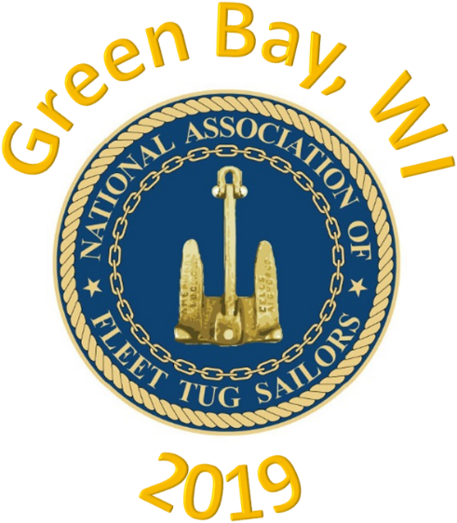

ADDITIONAL NAFTS MERCHANDISE
Although we will be driving to Green Bay, we will still only be bringing a limited amount of the merchandise to the Reunion. Because of this, if you want any specific items brought to the Reunion, please complete the following order form and send a check along with your Registration, tours, Banquet, etc. Please use the prices listed on the Ship’s Store Page in the Towline.
ITEM DESCRIPTION | SIZE | QUANTITY | PRICE | TOTAL PRICE
GRAND TOTAL

